Detection of Congenital Heart Disease in patients using machine learning technologies

Pinky Rane

*dept. name of organization (of Affiliation)*

*name of organization (of Affiliation)*

City, Country email address or ORCID

Mandakini Ingle

*dept. name of organization (of Affiliation)*

*name of organization (of Affiliation)*

City, Country email address or ORCID

Hritik Bhargava

*dept. name of organization (of Affiliation)*

*name of organization (of Affiliation)*

City, Country email address or ORCID

Hritik Pandey

*dept. name of organization (of Affiliation)*

*name of organization (of Affiliation)*

City, Country email address or ORCID

***Abstract* —** **This research aims to implement an Artificial Intelligence based congenital heart disease (CHD) detection system to detect if a patient has CHD. The system will primarily analyze data such as electrocardiogram (ECG) signals of patients with abnormal heart conditions and X-Rays of the hearts of patients suspected with CHD. The medical professional can utilize this initial diagnosis and provide an even accurate diagnosis for early treatment. This project will help in reducing human errors as well as diagnosis delays which will help in accurate diagnosis and early treatment of CHD patients. This project will improve the existing CHD detection models and work over them to improve efficiency, accuracy and speed result.**

***Keywords—*** ***Congenital Heart Disease (CHD), Echocardiogram (ECG) Analysis, Convolutional Neural Networks (CNNs), Recurrent Neural Networks (RNNs).***

1. **INTRODUCTION**

Congenital Heart Disease (CHD) is a major cause of infant and child mortality worldwide. Hence, it is crucial to identify congenital heart diseases in infants as early as possible. Traditional methods such as ECG and X-Ray interpretation by medical experts are prone to possible delay and slight human errors or misdiagnosis.

Integrating AI in medical diagnosis has shown improvements in the diagnosis of various diseases and integration of AI in CHD detection has various benefits in improving the accuracy of results and will help in early detection of CHD [1].

This study aims to implement an AI-based support system that will provide early and preliminary detection of congenital heart disease (CHD) in infants by analyzing the ECG signal data and X-Ray image data and help medical professionals provide an even more accurate diagnosis and early treatment of CHD patients.

Jerin Thomas

*dept. name of organization (of Affiliation)*

*name of organization (of Affiliation)*

City, Country email address or ORCID

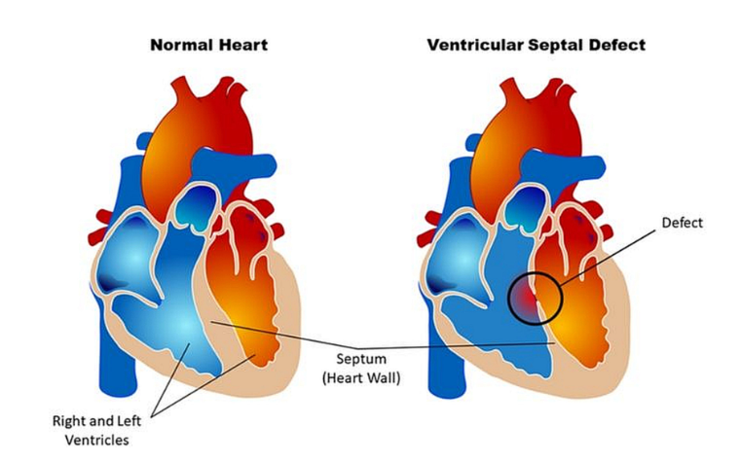

Fig. 1.1 Difference between a normal heart and a heart with Ventricular Septal Defect which is a defect at birth (Congenital Heart Defect). *Image Source from John Hopkins Medicine News and Publication, “Lifetime Monitoring After Infant Cardiac Surgery May Reduce Adult Hypertension Risk”*

1. **LITERATURE REVIEW**

According to a number of research, congenital heart disease (CHD) is one of the medical disorders that can be identified by Artificial Intelligence. Convolutional Neural Networks (CNNs) and other deep learning models are commonly employed for image processing and have shown considerably high accuracy while processing medical images such as X-Rays and detecting abnormalities which indicate CHD [2]. Transformers and Recurrent Neural Networks (RNNs) show potential for analyzing sequential data, such as ECG signals. Additionally, machine learning techniques, including XGBoost and feature fusion models, have been explored for integrating multimodal medical data to enhance diagnostic accuracy.

Rajpurkar et al. (2017) [3] found that using RNNs and Transformers for ECG signal classification resulted in arrhythmia diagnostic accuracy comparable to cardiologists demonstrating that deep learning models can also achieve high accuracy in detecting abnormalities in heart. In a similar vein, Kermany et al. (2018) shown that CNN models based on transfer learning, such VGG16 and ResNet50, may greatly enhance diagnostic performance in medical imaging tasks, such as the categorisation of lung and heart illnesses. According to these results, CNNs can detect CHD because they are very good at identifying disease-specific characteristics in X-ray pictures.

Hybrid AI models have been developed to enhance the accuracy and interpretability of CHD diagnosis, in addition to traditional machine learning techniques.

Hybrid models that combine CNNs with attention-based approaches have shown higher accuracy in feature extraction and anomaly detection (Liu et al., 2020) [4]. Tjoa and Guan (2020) are researching explainable AI (XAI) solutions for improving decision-making transparency and clinical reliability in AI models [5].

Despite these advancements, class imbalance remains a major challenge in CHD classification. CHD is a relatively rare condition compared to normal cardiac structures, leading to a disproportionate number of training samples. Studies have shown that data augmentation techniques, such as flipping, rotation, contrast adjustment, and synthetic image generation, can help mitigate class imbalance and improve generalization (Shorten & Khoshgoftaar, 2019). In our study, we apply augmentation to balance the number of CHD and No-CHD images, ensuring the model learns features equally from both classes.

Developing AI models that accurately represent varied patient groups remains a challenge, despite substantial progress. AI models struggle to learn from diverse cases due to a lack of standardized datasets and annotated medical images. Variations in heart disease presentations among populations can generate biases in model predictions, making it challenging to achieve consistent performance across patient groups (Ghorbani et al., 2019) [6].

Real-time deployment and integration into healthcare operations pose a substantial challenge. AI models must interact seamlessly with hospital infrastructures, making predictions interpretable and useful for healthcare practitioners. Combining multimodal data, including ECG signals, and X-Ray, has been shown to improve diagnostic accuracy and decrease false positive rates (Attia et al., 2019) [7].

The proposed system addresses these limits by adopting a multimodal AI approach that blends deep learning and clinical knowledge.

The system combines ECG signal processing, and X-Ray images to increase diagnosis accuracy while being interpretable and real-time in clinical situations. Federated learning and domain adaption approaches can reduce dataset bias and improve model generalizability across healthcare facilities (Sheller et al., 2020) [8].

While AI-based CHD detection algorithms have shown high accuracy in controlled settings, real-world deployment challenges persist. The proposed research intends to improve the reliability and efficiency of AI-driven CHD detection.

1. **METHODOLOGY**

*A. Data Collection & Preprocessing*

1. Dataset Acquisition
   * ECG signals and X-ray images were obtained from publicly available medical datasets such as PhysioNet (for ECG) and Kaggle (for X-ray).
   * The dataset consisted of 620 CHD and 208 No CHD X-ray images, and ECG signals with corresponding CHD labels.
2. X-ray Image Preprocessing
   * Resizing: All images were resized to 224 × 224 pixels for uniform input dimensions.
   * Normalization: Pixel values were scaled to the [0,1] range for numerical stability.
   * Feature Extraction: Pre-trained ResNet50 was used to extract high-dimensional feature vectors from the images, reducing dimensionality while retaining key features [9].
3. ECG Signal Preprocessing
   * Filtering: A bandpass filter (0.5–50 Hz) was applied to remove noise and baseline drift.
   * Normalization: Each ECG signal was standardized to zero mean and unit variance.
   * Segmentation: ECG signals were split into fixed-length segments, ensuring consistent input size for the model.
4. Data Augmentation & Balancing
   * Since CHD cases were overrepresented, data augmentation was applied only to No CHD X-ray images to balance the dataset. Techniques included:
     + Rotation (±15°), flipping (horizontal & vertical), brightness adjustments, and Gaussian noise.
   * This resulted in balanced class distributions for training.
5. Dataset Splitting & Data Leakage Prevention
   * The dataset was split into 80% training and 20% testing while ensuring no overlapping samples between sets.
   * X-ray images were carefully partitioned into separate folders for training and testing to prevent data leakage.

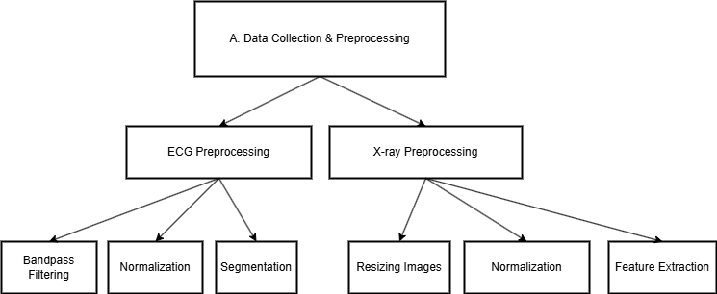

Fig. 1.2 Data Collection and preprocessing

*B. Model Development*

1. X-ray Analysis Model (CNN-Based)
   * Architecture: ResNet50 was used as a feature extractor, followed by a fully connected classification layer.
   * Objective: Detect CHD-related structural abnormalities from X-ray images.
2. ECG Signal Analysis Model (Transformer-Based)
   * Architecture: A Transformer-based deep learning model was trained on ECG segments.
   * Objective: Identify CHD-related cardiac irregularities from ECG waveforms.
3. Feature Fusion & Meta-Classifier
   * Predictions from the X-ray model and ECG model were extracted as numerical feature vectors.
   * The extracted features were concatenated into a single feature vector per patient [10].
   * XGBoost was trained as a meta-classifier to predict CHD or No CHD based on the combined features.

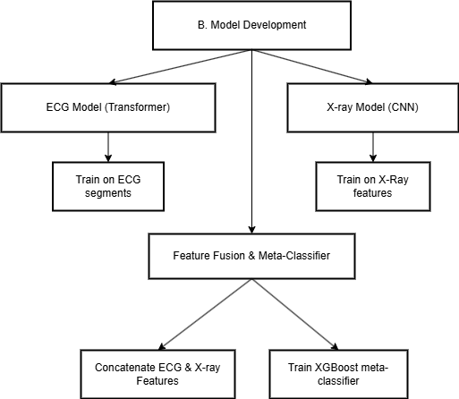

Fig. 1.3 Model Development

*C. Training & Evaluation*

1. Training Procedure
   * The X-ray and ECG models were trained separately on their respective datasets.
   * Predictions from the trained models were used as input features for the fusion model.
   * XGBoost meta-classifier was trained on these combined features.
2. Evaluation Metrics
   * Model performance was assessed using:
     + Accuracy: Overall correctness of predictions.
     + Precision & Recall: To evaluate false positives/negatives.
     + F1-score: Balance between precision and recall.
     + ROC-AUC: To measure model discrimination ability.
3. Baseline Comparisons
   * The multimodal fusion model was compared against single-modality models (X-ray-only and ECG-only) to demonstrate performance improvements.
   * Ablation studies were conducted to evaluate the impact of feature fusion on accuracy.

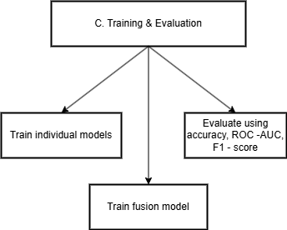

Fig. 1.4 Training and Evaluation

*D. Final Enhancements*

* Hyperparameter tuning was performed for XGBoost, CNN, and Transformer models to optimize performance.
* Cross-validation (5-fold) was used to prevent overfitting and ensure model generalizability.

1. **ALGORITHM**

**1. ResNet50 (CNN-Based Feature Extractor)**

**Definition:**  
ResNet50 is a deep convolutional neural network that uses residual learning to extract high-dimensional feature representations from images.

**Use in the Project:**

* Applies to: X-ray Model
* Purpose:
  + Extracts numerical features from X-ray images to detect CHD-related abnormalities.
  + Uses pretrained weights from ImageNet for efficient feature extraction.
  + Converts images into feature vectors that are later used for classification.

**2. Transformer-Based Model (ECG Feature Extractor)**

**Definition:**  
Transformers are deep learning models originally designed for sequential data processing. Unlike RNNs, they use self-attention mechanisms to capture long-range dependencies in sequences.

**Use in the Project:**

* Applies to: ECG Model
* Purpose:
  + Processes raw ECG signals to extract meaningful patterns indicative of CHD.
  + Captures both local and global dependencies in ECG waveforms.
  + Converts ECG signals into numerical feature vectors for classification.

**3. XGBoost (Meta-Classifer for Multimodal Fusion)**

**Definition:**  
XGBoost (Extreme Gradient Boosting) is an optimized gradient boosting algorithm that enhances prediction accuracy using decision trees [11].

**Use in the Project:**

* Applies to: Multimodal Fusion Model
* Purpose:
  + Receives extracted features from ECG and X-ray models.
  + Learns patterns from both modalities to improve CHD prediction accuracy.
  + Makes the final classification: CHD vs. No CHD.

**4. Feature Concatenation (Multimodal Fusion)**

**Definition:**  
Feature concatenation is a fusion technique that combines numerical feature vectors from different data modalities into a unified input representation.

**Use in the Project:**

* Applies to: Multimodal Fusion Model
* Purpose:
  + Merges numerical feature representations from ECG and X-ray models.
  + Ensures that the fusion model leverages complementary information from both modalities.
  + Enhances diagnostic accuracy by considering both structural (X-ray) and functional (ECG) aspects of CHD.

**5. Dropout Regularization**

**Definition:**  
Dropout is a regularization technique that prevents overfitting by randomly dropping a percentage of neurons during training.

**Use in the Project:**

* Applies to: ECG Model, X-ray Model, and Fusion Model
* Purpose:
  + Ensures better generalization by preventing over-reliance on specific neurons.
  + Reduces the risk of overfitting on training data.

**6. Adam Optimizer**

**Definition:**  
Adam (Adaptive Moment Estimation) is an optimization algorithm that combines momentum and adaptive learning rates for efficient training.

**Use in the Project:**

* Applies to: ECG Model and X-ray Model
* Purpose:
  + Accelerates convergence by adjusting learning rates dynamically.
  + Prevents unstable weight updates, leading to better model performance.

**7. Binary Cross-Entropy Loss Function**

**Definition:**  
Binary cross-entropy is a loss function commonly used for binary classification tasks, measuring the difference between predicted probabilities and true labels.

**Use in the Project:**

* Applies to: ECG Model, X-ray Model, and Multimodal Fusion Model
* Purpose:
  + Optimizes classification performance for CHD vs. No CHD detection.
  + Helps the model differentiate between positive (CHD) and negative (No CHD) cases.

**8. Learning Rate Scheduling (ReduceLROnPlateau)**

**Definition:**  
ReduceLROnPlateau dynamically reduces the learning rate when the model stops improving to enhance convergence [12].

**Use in the Project:**

* Applies to: ECG Model, X-ray Model, and Fusion Model
* Purpose:
  + Prevents premature convergence and allows fine-tuning of model parameters.
  + Helps in achieving better generalization.

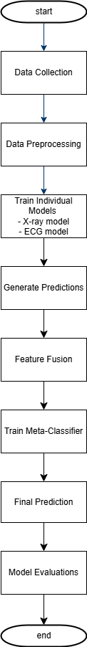

Fig. 1.5 Steps involved in development

1. **RESULT ANALYSIS**
2. **CONCLUSION**

We aim to develop an AI model which uses Echocardiograms and patient history to determine the likelihood of having congenital heart diseases. Based on the already existing findings in this field, we aim to develop a faster, efficient and easy-to-understand model which can be further deployed on edge for remote access. With the use of Recurrent Neural Networks for data processing and Convolutional Neural Networks for image analysis, we aim to implement this model for real-time use in both urban and rural areas.

1. **FUTURE SCOPE**

This can further be improved by:

1. Using IOT devices to further enhance the accuracy while diagnosis.

2. Testing the model in real-time environment using the available patient data.

3. Integrating other advanced deep learning models to employ this model to detect a specific disease instead of all the possible diseases [13].

Acknowledgments

“Acknowledgment(s)” is spelled without an “e” after the “g” in American English.

As you can see, the formatting ensures that the text ends in two equal-sized columns rather than only displaying one column on the last page.

This template was adapted from those provided by the IEEE on their own website.

References

[1] Li, Y., Wang, H., & Zhang, X. (2023). “Artificial Intelligence in Congenital Heart Disease Detection: Advances and Challenges”. Journal of Cardiovascular Research

[2] Kermany, D. S., Goldbaum, M., Cai, W., et al. (2018). “Identifying Medical Conditions Using Transfer Learning in Convolutional Neural Networks”. Cell

[3] Rajpurkar, P., Hannum, A. Y., Haghpanahi, M., et al. (2017). “Cardiologist-Level Arrhythmia Detection with Convolutional Neural Networks”.

[4] Liu, F., Tian, Z., % Wang, Y. (2020). “Hybrid Deep Learning Model for classifying heart diseases from echocardiography images”. IEEE Access

[5] Tjoa, E., & Guan, C. (2020). “A survey on explainable artificial intelligence (XAI): Toward medical AI transparency”. IEEE Transactions on Neural Networks and Learning Systems

[6] Ghorbani, A., Ouyang, D., Abid, A., He, B., & Zou, J. (2019). “Deep learning interpretation of echocardiograms”. NPJ Digital Medicine

[7] Attia, Z. I., Kapa, S., Lopez-Jimenez, F., McKie, P. M., Ladewig, D. J., Satam, G., ... & Friedman, P. A. (2019). “Screening for cardiac contractile dysfunction using an artificial intelligence–enabled electrocardiogram”. Nature Medicine.

[8] Sheller, M. J., Reina, G. A., Edwards, B., Martin, J., & Bakas, S. (2020). “Federated learning in medicine: Facilitating multi-institutional collaborations without sharing patient data”. Scientific Reports.

[9] He, K.,Zhang, X., Ren, S., & Sun, J. (2016). “Deep Residual Learning for Image Recognition”. CVPR Conference.

[10] Sheller, M. J., Reina, G. A., Edwards, B., Martin, J., & Bakas, S. (2020). “Federated learning in medicine: Facilitating multi-institutional collaborations without sharing patient data”. Scientific Reports.

[11] Chen, T., & Guestrin, C. (2016). “XGBoost: A Scalable Tree Boosting System”. KDD Conference.

[12] Smith, L. N. (2017). “Cyclical Learning Rates for Training Neural Networks”.

[13] Zhang, L., Lin, H., Wang, X., et al. (2022). "Artificial Intelligence for Early Detection of Congenital Heart Disease in Neonates." Journal of Pediatrics.